WELCOME TO 2019-2020
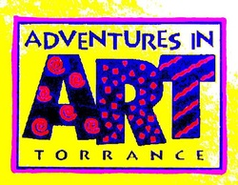

AT JEFFERSON MIDDLE SCHOOL
CHAIR: CARA McCALLUM, 714-742-7637 CELL
SUPPLY CHAIR: JUDY LIBERTOR, 562-243-6037 CELL
EMAIL: JMSAIAART@GMAIL.COM
WEBSITE: JMSAIAART.WIXSITE.COM/HOME
VOLUNTEER INFO
• AIA at JMS is taught in your child’s PE class. Independent PE students may take AIA in the PE class of their free period, as long as their parent alerts the school office in advance.
• EVERY SCHOOL YEAR, all volunteers must complete new volunteer paperwork and have it verified through the JMS office, which takes about one week. Cleared volunteer paperwork from other TUSD schools is valid, but volunteers must provide a copy to the JMS office. Download the paperwork from the AIA website after 9/4. You must be a cleared volunteer to be on campus for any reason during school hours.
• You will be assigned to help in your child’s PE class for each of this year’s five AIA projects, unless you specify otherwise. SignUpGenius links will be sent out for each project to help you keep track of the schedule. We also appreciate volunteers who can help in more than one class during each project.
YOUR HELP IS NECESSARY TO KEEP AIA RUNNING, AND YOU ARE VERY APPRECIATED! THANK YOU!
Adventures in Art ~ Torrance

Motto: Where art becomes an adventure for life!
Description: Adventures in Art (AIA) is a volunteer run fine arts program annually providing training for five elementary school projects and five middle school projects for school volunteers from participating Torrance schools. Projects are written by local artist/art educators and selected by AIA to give students hands-on opportunities to learn fine-arts methods while working with quality art materials. Participating schools send their school volunteers to attend AIA’s Docent Orientation and five grade level art Workshops to learn projects directly from the artist/educators. School volunteers return to their schools to lead students through these projects in their own classrooms. AIA schools celebrate students’ art work and continuing artistic development by creating annual student art exhibits on their campuses featuring current year projects.
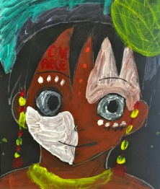
Philosophy: Adventures in Art philosophy is grounded in the belief that a child’s art experience should focus on the process, rather than the finished product and provide opportunities for experimentation resulting in a child’s discovery of unique art solutions. The AIA program is dedicated to developing the creative spirit in children, through a variety of art mediums, in a non-judgmental and non-threatening atmosphere.

Mission Statement: The goal of the Adventures in Art program is to provide fine art enrichment opportunities for children that encourage the development of a solid foundation of artistic exploration that will ideally interest and inspire them in creative and innovative works beyond our program’s annual projects.
8/6/2019

