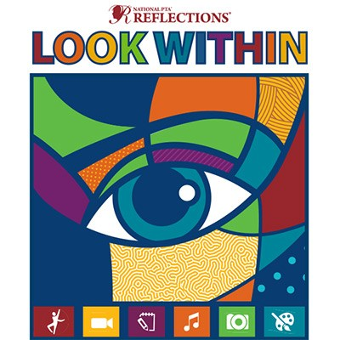
Let your creative side shine in the
2019-2020 Reflections Program
For more information please contact Debbie Gan Callereflections@gmail.com
All entries due by October 11, 2019

