Hello! Congratulations to your student
on completing the i-Ready Diagnostic!
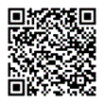
What is the i-Ready Diagnostic?
The Diagnostic is an adaptive assessment that identifies students’ strengths and opportunities for growth.
That information helps determine how to best support their learning. Watch this video to learn more.
How can I access my student’s results?
- Log in to your student’s i-Ready Dashboard using their district or school’s portal credentials and then click on the
i-Ready icon. If your district does not use a portal, visit i-ReadyConnect.com and log in using the credentials provided by their teacher(s).
- Click on the For Families dropdown and select the For Families report.
- Enter your District’s Report Code P3YX53.
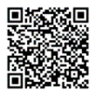
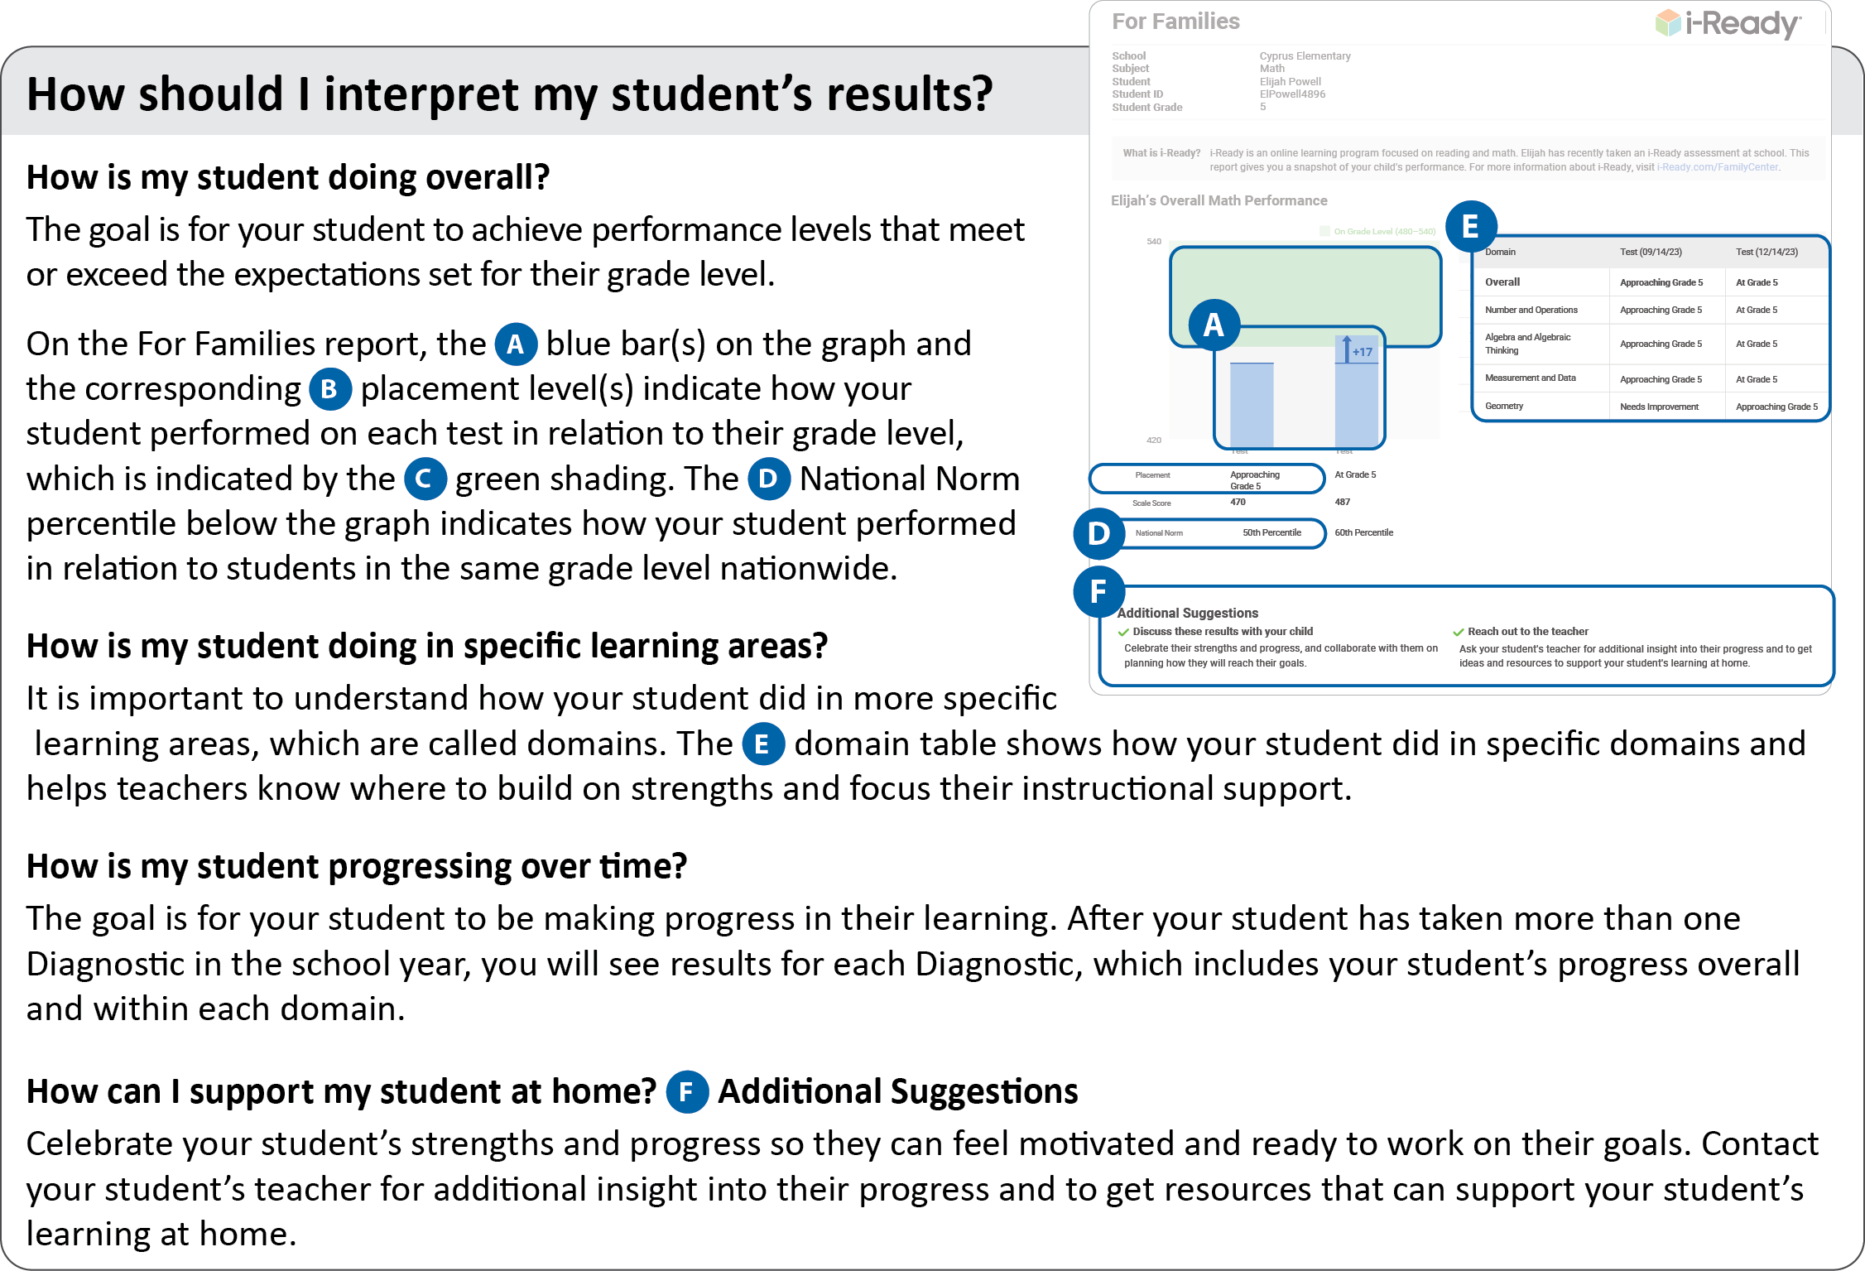
For more information and support, visit the i-Ready Family Center: Understanding Diagnostic Results.
Thank you again for your continued partnership and support of your student’s learning.
Please contact your child’s Math or English teachers with any questions.
Best,
Calle Mayor ELA and Math Teachers

