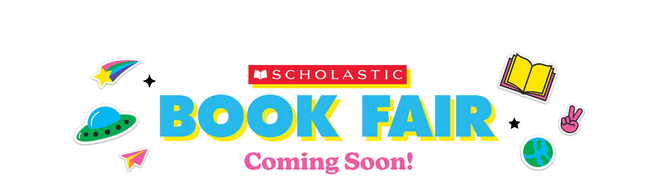
Dear Parents and Families:

Get Ready! The Scholastic Book Fair is coming our way (YAY!). Choosing their own books empowers kids and inspires them to become Bolder, Prouder, and Stronger Readers. AND—as always—every book they buy earns rewards for our school.

Here’s what you need to know about the Fair, which will take place from December 5th - 9th at the Calle Mayor Library.

This year, say goodbye to cash and hello to eWallet—your child’s digital payment account.
Before the Fair, set up eWallet for worry-free, cash-free purchases.

If you can’t make it to the Fair, then shop at our school’s Online Book Fair. All orders ship directly to your home, and shipping is free for book orders over $25. Your online orders will also benefit our school.

Visit our Book Fair homepage to learn more and get started with eWallet and online shopping:
https://www.scholastic.com/bf/callemayorms

The countdown to more Bookjoy is on! Catch you at the Fair!

Happy reading,

David Mosley
Principal
Calle Mayor Middle School

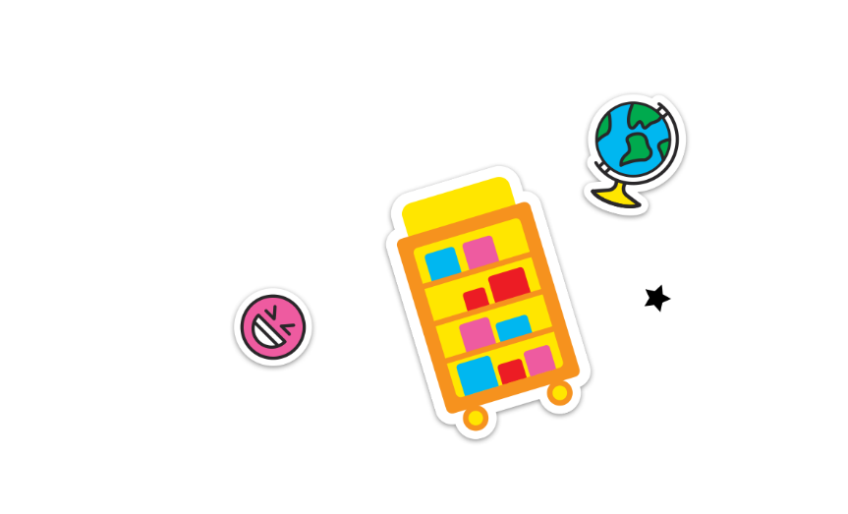
Permission to reproduce this item is granted by Scholastic Book Fairs®.
©2022 Scholastic Inc. All rights reserved. 2580250 F22 • 2579756

