Accessing TUSD Online Pay Stubs
1. Make sure you are signed into your TUSD Gmail account, not a personal Gmail. 2. Open another tab on your browser and navigate to
https://districtbusinessportal.lacoe.edu/
3. Click the checkbox to agree to the LACOE Acceptable Use Policy. 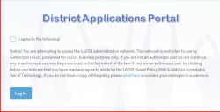
4. Select Google to authenticate.
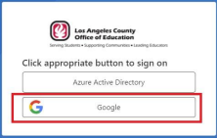
5. Click on my Documents
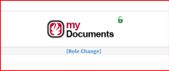
6. Click on Pay Stubs on the left navigation menu to access pay stubs.