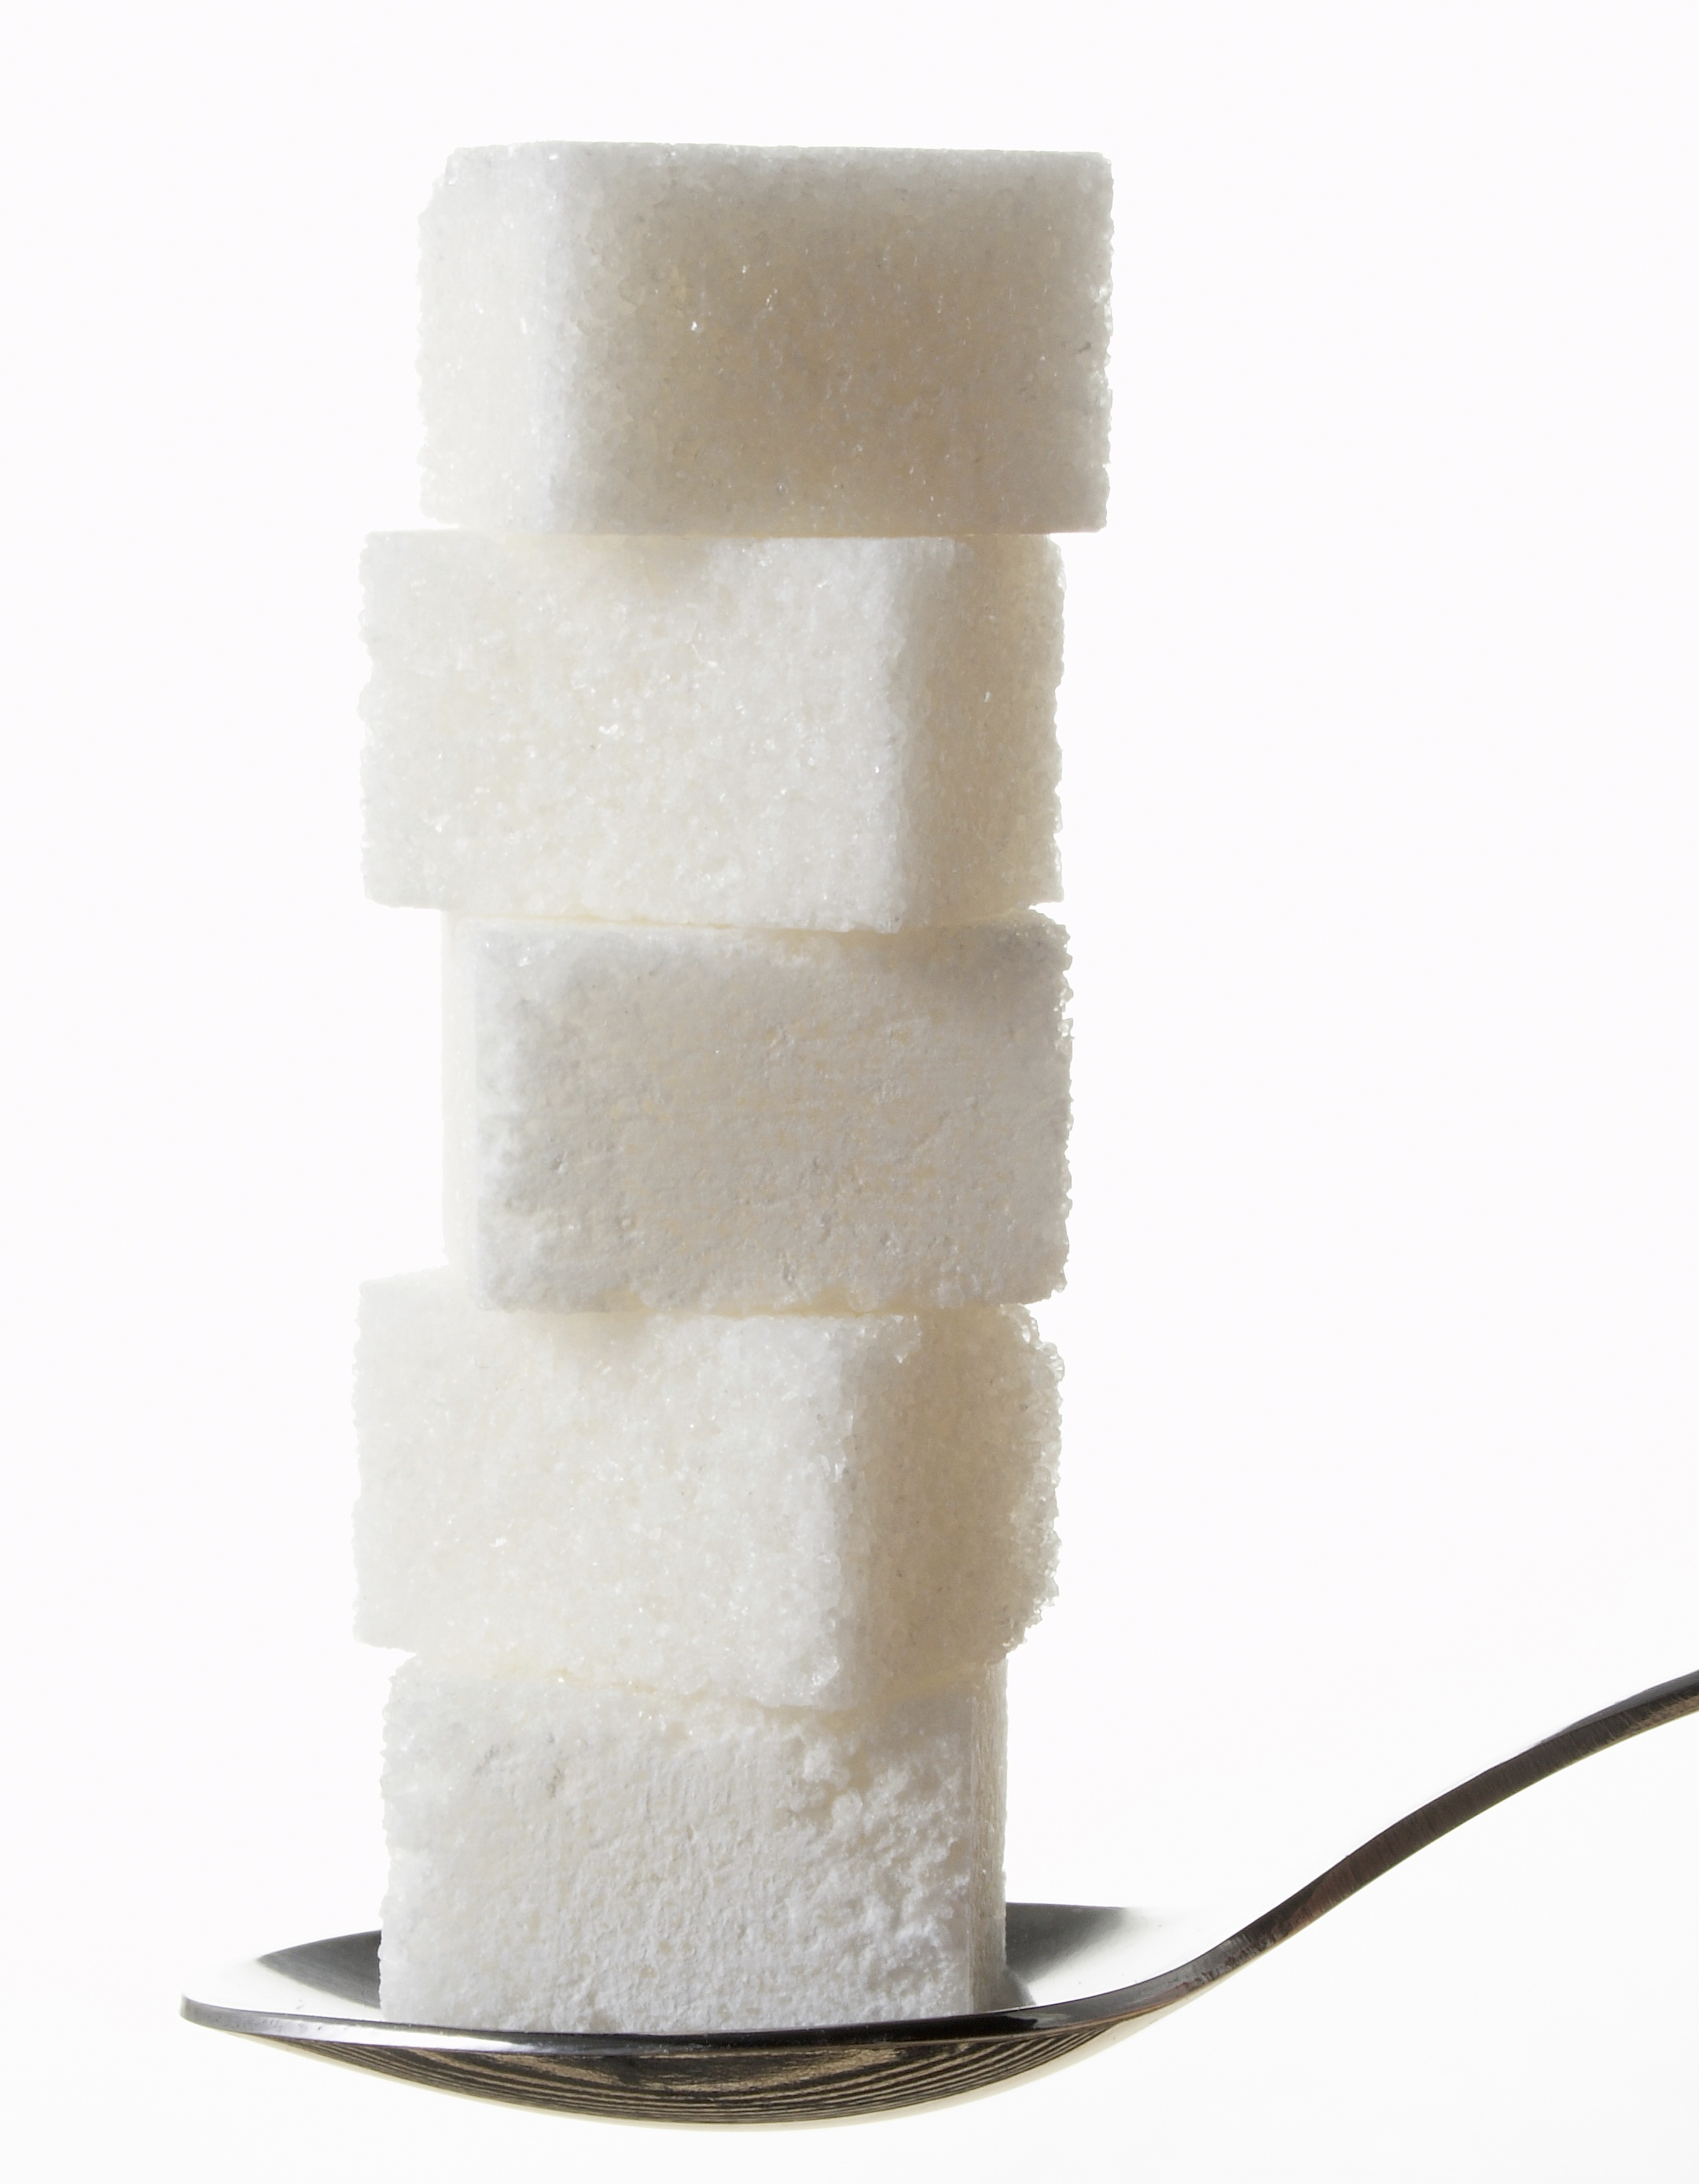HOW MANY SUGAR CUBES?

Directions: For each food item, convert the grams of sugar into the number of sugar cubes one serving of the food contains. (Remember, to convert grams of sugar into cubes (or teaspoons) or sugar, divide the grams of sugar by 4).

Example:

Food | Grams Sugar  per Serving | Divide by 4 | Cubes of Sugar per Serving
Glazed Doughnut  (One Twist) | 24 | ÷ 4 | = 6 Cubes

Your Turn!

Food | Grams Sugar  per Serving | Divide by 4 | Cubes of Sugar per Serving
Maple Syrup  (2 Tablespoons) | 28 | ÷ 4 | = _______Cubes
Gummy Bears  (10 Small Bears) | 12 | ÷ 4 | = _______Cubes
Ice Cream Bar  (One Small) | 20 | ÷ 4 | = _______Cubes
Chocolate Chip Cookie  (One Large) | 16 | ÷ 4 | = _______Cubes
Lemon-Lime Soda  (12-ounce Can) | 32 | ÷ 4 | = _______Cubes

REMEMBER: For your best health, don’t take in (eat and drink) more than 8 sugar cubes of added sugar per day! Choose what you like best, and enjoy a small portion!
Created by Emily Parker, MS, RD – Torrance Memorial Medical Center

